Exercise 1: Service
In this exercise, you will disable service %Service_Terminal on Ubuntu, and see how service controls connections to IRIS.
For this exercise, you need to know the following:
• %Service_Console is only for Windows and %Service_Terminal is only for Linux/UNIX.
• To enable/disable a service, use the Management Portal:
System Administration > Security > Services > Select service > Select Service enabled.
• On Ubuntu, to access your instance using %Service_Terminal, type the following: $ iris session iris
All below operations are on irisa instance:
1. Access IRIS by %Service_Terminal:
$ iris session iris
After login IRIS successfully, quit IRIS session by typing h:
USER>h
2. Disable %Service_Console or %Service_Terminal, depending on your operating system.
Open a Terminal session. What happened?
________________________________________________________________________________ 3. Re-enable the service.
docker exec -it irisa iris session IRIS
Exercise 2: Authentication
In this exercise, you will test different authentication mechanisms using %Service_Terminal on Ubuntu.
For this exercise, you need to know the following:
• %Service_Console is only for Windows and %Service_Terminal is only for Linux/UNIX.
• To enable an authentication mechanism for the instance, use: System Administration > Security > System Security > Authentication / Web Session Options > Select authentication mechanism.
• To enable a service, use the Management Portal:
System Administration > Security > Services > Select service > Select Service enabled.
• To change the authentication method of a service, use the Management Portal: System Administration > Security > Services > Select service > Select or Clear authentication method.
• On Ubuntu, to access your instance using %Service_Terminal, type the following: $ iris session iris
• To determine the name of the user you are logged in as, use:
USER>write $USERNAME
All below operations are on irisa instance:
1. Add Operating System as a valid authentication mechanism for this instance.
2. Test each authentication method in the chart below for the %Service_Terminal (Ubuntu) and complete the chart with the results. Make sure to clear all authentication methods for the service other than the one being tested.
If you are prompted, login using SuperUser.
Authentication Mechanism | Are you  prompted for a username? | What username/password was used?
Operating
System
Password

3. When you were not prompted for a username, how did the system determine which username to use?
______________________________________________________________________________ _____________
4. Add Unauthenticated as valid for %Service_Console or %Service_Terminal. 5. Verify you have Login Failure and Protect system audit events enabled for auditing.
6. Try to log in as Unauthenticated by pressing ENTER for Username and Password. What is the error message in the audit log for the login attempt?
______________________________________________________________________________ _____________
This time you passed authentication, but failed authorization. This means UnknownUser was considered valid but did not have the correct permission (authorization). Next module you will learn more about authorization.
7. Try to log into a Terminal session with an invalid password. According to the audit log entry, what authentication method failed?
______________________________________________________________________________ _____________
8. Add Operating System as valid for %Service_Console or %Service_Terminal.
9. Bring up a Terminal session. According to the audit log entry, what authentication was used?
______________________________________________________________________________ _____________
10. Specify Password as the only valid authentication method for %Service_Console or %Service_Terminal.
Exercise 3: Authentication – TOTP
In this exercise, you will test TOTP for IRIS System Management Portal. For this exercise, you need to know the following:
• To enable an authentication mechanism for the instance, use:
System Administration > Security > System Security > Authentication / Web Session Options > Select authentication mechanism.
1. Enable Time-based One-time authentication. Check Allow Time-based One-time authentication, and input issuer name, like MyIRISServer
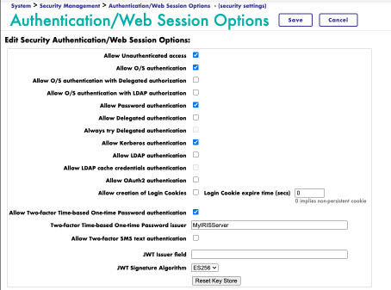2. Enable applications to use TOTP. Here application is the System Management Portal. Go to SMP>System Administration>Security>Application> Web Application, click /csp/sys Check Two-factor Time-based One-time Password, and save the change
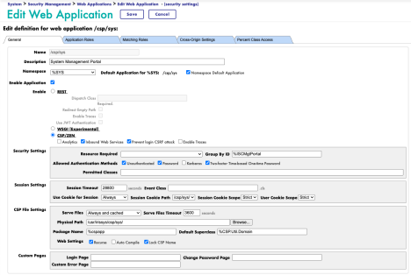
3. Configure users to use TOTP as 2FA
Go to SMP>System Administration>Security>Users, click on SuperUser
check Time-based One-time Password enabled, and check Display Time-Based One time Password QR Code on next login, and save the change
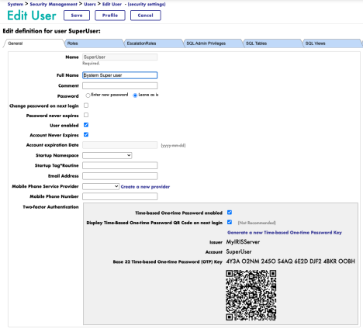
4. Configure MS Authenticator app on your mobile phone
Open MS Authenticator on your mobile phone, scan above QR code to create a new account.
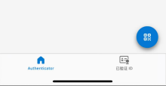
5. Login SMP with SuperUser, and then input Verification code showed on MS Authenticator app. It should lead you into SMP.
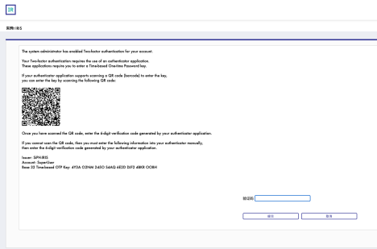
Exercise 4: Authorization: Basics
In this exercise, you will create users and roles for the User namespace.
For these steps, you need to know the following points:
• To create a user, use the Management Portal:
System Administration > Security > Users > Create New User.
• To create a role, use the Management Portal:
System Administration > Security > Roles > Create New Role.
• To assign privileges to a role, use the Management Portal:
System Administration > Security > Roles > Select the role. Click Add. Select the resource. Click Ok and Save.
• To assign a user to a role, use the Management Portal.
System Administration > Security > Roles > Select the role. Click the Members tab. Move the user to the Selected box, and click the Assign button.
1. Create the users and roles as described in the table below. Notice all newly created roles are empty except for AppDeveloper. Assign the user to the role indicated. For any fields not specified in the table, accept the default or leave empty.
Note: The User Description below describes what a role will eventually be able to do (once the next few module exercises are completed). Do not implement anything based on the description—it is for informational purposes only.
Username/password and  User Description | Startup  Namespace | Role Name
Chris/demo  Customer data admin - Administrators of Customer data |  | CustAdmin
Olaf/demo  Overall admin - Administrators for Phonebook application and all related data. | USER | OverallAppAdmin
Anita/demo  Application developer - Developers for Phonebook application. | USER | AppDeveloper  (Copy from:  %Developer)
Bo/demo  Backup operator - System operators. Able to perform limited functionality, such as backups, via the Management Portal |  | %Operator  (existing role)

2. Verify Anita, the Application developer, can log into Terminal. If you are not being prompted for a username when bringing up Terminal, change the
%Service_Console to only allow Password, not Operating System.
3. Verify Anita can read and write to the USER database.
To do so, create and write the global ^anita in the USER namespace.
USER>set ^anita = 1
USER>write ^anita.
4. Can Chris, the Customer admin, log into Terminal? Why or why not? ______________________________________________________________________________ ___
5. Try to log into the Management Portal as Anita, the application developer.
What happened?
_________________________________________________________________________________ __________
Why does this behavior differ from logging in as SuperUser?
_________________________________________________________________________________ _________________________________________________________________________________ ____________________
Exercise 5: Authorization: Application
In this exercise, you will create resource and change web application security setting. 1. Create a FHIR Server
Create a new namespace and database, named as FHIR.
Go to SMP>Health, click on FHIR,select FHIR Server Management, click Add new server.
Select FHIR in Namespace, input Name as MyFHIRServer, keep others as default, click create.
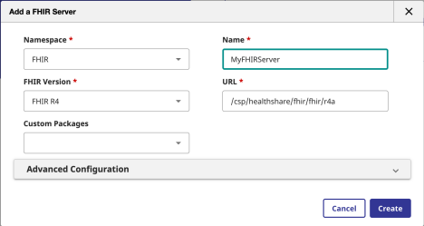2. Test the application by Postman
Use Postman to test connection to FHIR Server
• GET http://127.0.0.1:8080/csp/healthshare/fhir/fhir/r4/metadata
• Authentication Type: Basic Authentication
• UserName: Sam
• Password: demo
what is in response?
_________________________________________________________________________________ __________
3. Create resource
Go to SMP>System Administration>Security>Resource. Click button Create New Resource, input resource name as MyFHIRSvr, save.
4. Change the web application
Go to SMP>System Administration>Security>Application>Web Application. Select /csp/healthshare/fhir/fhir/r4, select MyFHIRSvr in dropdown list of Resource Required, and save.
5. Try step 2 again.
what is in response this time, and why?
______________________________________________________________________________ _____________
6. Try again with user SuperUser.
what is in response this time, and why?
______________________________________________________________________________ _____________

